**E Commerce Application on IBM Cloud Foundry**

|  |  |
| --- | --- |
| **Date** | **29092023** |
| **Team ID** | **8936** |
| **Project Name** | **E Commerce Application on IBM Cloud Foundry** |

**INDRODUCTION:**

The revolving digital landscape has transformed the way businesses operate, with ecommerce playing a pivotal role in connecting consumers and vendors on a global scale. In this context, the deployment of robust and scalable ecommerce applications becomes essential for businesses aiming to thrive in the competitive market. This project focuses on developing an ecommerce application leveraging the capabilities of IBM Cloud Foundry, a platform that provides cloudnative capabilities for building, deploying, and managing applications.

**Scalability** refers to the ability of a system to handle an increasing amount of load or demand by adding resources or scaling horizontally. In the case of an ecommerce application on IBM Cloud, here are some key aspects of scalability:

1. Vertical Scaling vs. Horizontal Scaling:

Vertical Scaling: This involves adding more power to your existing server, such as increasing CPU, RAM, or storage. However, there's a limit to how much you can scale vertically.

Horizontal Scaling: This involves adding more servers to distribute the load. IBM Cloud allows you to easily add more virtual machines or containers to your application to handle increased traffic.

2. Load Balancing:

Use IBM Cloud's load balancing services to distribute incoming network traffic across multiple servers. This ensures that no single server bears too much load, optimizing performance and preventing downtime.

3. Autoscaling:

Implement autoscaling policies that automatically adjust the number of compute resources based on traffic or performance metrics. IBM Cloud provides autoscaling features that can dynamically scale your application in response to demand.

4. Container Orchestration:

If your ecommerce application is containerized using technologies like Docker, Kubernetes can be employed for container orchestration. IBM Cloud Kubernetes Service allows you to manage the deployment, scaling, and operation of application containers.

5. Database Scaling:

As your user base grows, the demand on your database increases. IBM Cloud offers scalable databases, such as Db2 on Cloud or Databases for MongoDB, which can be easily scaled to handle more data and requests.

6. Content Delivery Network (CDN):

Leverage IBM Cloud's CDN services to cache and deliver static content closer to users. This reduces the load on your servers and improves the overall speed and responsiveness of your ecommerce application.

7. Global Deployment:

If your ecommerce application serves a global audience, consider deploying it in multiple IBM Cloud regions. This reduces latency for users in different geographical locations and enhances overall performance.

8. Monitoring and Analytics:

Utilize IBM Cloud monitoring and analytics tools to gain insights into the performance of your application. Monitor key metrics, set up alerts, and use analytics to identify areas for optimization and improvement.

**Reliability** is crucial for any ecommerce application to ensure consistent and uninterrupted service. When considering the reliability of an ecommerce application hosted on IBM Cloud, several factors come into play:

1. High Availability Architecture:

Design your ecommerce application with high availability in mind. Distribute your application across multiple availability zones offered by IBM Cloud to ensure redundancy. This way, if one zone experiences issues, traffic can be redirected to another without causing downtime.

2. Backup and Disaster Recovery:

Implement regular backup strategies for your data and systems. IBM Cloud provides services and tools for automated backup and disaster recovery. In the event of a failure or data loss, you can quickly restore your application to a previous state.

3. Service Level Agreements (SLAs):

Understand and leverage IBM Cloud's SLAs. IBM Cloud provides SLAs for various services, ensuring a certain level of uptime and performance. Choose services with SLAs that align with the reliability requirements of your ecommerce application.

4. Monitoring and Logging:

Utilize IBM Cloud's monitoring and logging tools to continuously track the performance and health of your application. Set up alerts for critical events or performance thresholds to proactively address potential issues before they impact users.

5. Security Measures:

Implement robust security measures to protect your ecommerce application from cyber threats. IBM Cloud offers security services, such as IBM Cloud Security Advisor and Key Protect, to help secure your application and data.

6. Regular Maintenance and Updates:

Keep your application and underlying infrastructure up to date with the latest patches and updates. IBM Cloud provides tools and services that facilitate the seamless deployment of updates, ensuring that your application remains secure and reliable.

7. Scalability for Traffic Spikes:

As mentioned in the previous response, scalability is closely tied to reliability. Ensure that your ecommerce application can scale horizontally to accommodate sudden spikes in traffic without compromising performance.

8. Geographical Redundancy:

Consider deploying your ecommerce application in multiple geographic regions offered by IBM Cloud. This not only improves performance for users in different locations but also adds an additional layer of redundancy in case one region faces disruptions.

9. Testing and Quality Assurance:

Implement thorough testing and quality assurance processes before deploying updates or new features. Use IBM Cloud's testing and development services to simulate realworld scenarios and identify potential issues before they impact production.

**Ease of deployment** is a critical factor for the efficiency and agility of an ecommerce application. IBM Cloud offers several features and services that contribute to the ease of deployment for such applications:

1. Container Orchestration with Kubernetes:

IBM Cloud provides a managed Kubernetes service that simplifies the deployment, scaling, and management of containerized applications. By using Kubernetes, you can package your ecommerce application and its dependencies into containers, making it easier to deploy consistently across different environments.

2. Cloud Foundry for Application Deployment:

Cloud Foundry on IBM Cloud is a platformasaservice (PaaS) offering that automates many aspects of the deployment process. It supports multiple programming languages and frameworks, making it easier to deploy and manage your ecommerce application without dealing with the complexities of infrastructure.

3. DevOps Tooling:

IBM Cloud offers a suite of DevOps tools that facilitate continuous integration and continuous delivery (CI/CD) pipelines. These tools, such as Jenkins and Travis CI, enable automated testing, building, and deployment of your application, streamlining the release process.

4. Integration with DevOps Services:

IBM Cloud integrates with popular DevOps services, allowing you to connect your source code repositories (e.g., GitHub, GitLab) directly with your deployment pipelines. This integration streamlines the process of deploying updates and new features.

5. Prebuilt Images and Templates:

IBM Cloud provides prebuilt images and templates for various application stacks. You can use these to quickly deploy common components of your ecommerce application, reducing the time and effort required for manual setup.

6. Infrastructure as Code (IaC):

Leverage tools like Terraform or IBM Cloud Schematics to define your infrastructure as code. This allows you to automate the provisioning and configuration of resources, ensuring consistency and repeatability in your deployments.

7. Autoscaling and Load Balancing:

Set up autoscaling policies and load balancing configurations to handle varying levels of traffic. IBM Cloud's autoscaling features can automatically adjust the number of resources based on demand, ensuring that your ecommerce application can handle traffic spikes.

8. Monitoring and Analytics for Deployment Health:

Utilize IBM Cloud's monitoring and analytics tools to track the health of your application during and after deployment. This helps in identifying and addressing issues quickly, ensuring a smooth deployment process.

9. Rollback Mechanism:

Implement a rollback mechanism in your deployment strategy. IBM Cloud allows you to define multiple versions of your application, making it easier to roll back to a previous version in case an issue is detected postdeployment.

**Security** is paramount for an ecommerce application, especially when dealing with sensitive customer information and financial transactions. When hosting an ecommerce application on IBM Cloud, here are key aspects to consider for security:

1. Data Encryption:

Utilize SSL/TLS protocols to encrypt data transmitted between users and your application. IBM Cloud provides services like IBM Cloud Certificate Manager to manage and automate SSL/TLS certificates.

2. Identity and Access Management (IAM):

Implement robust IAM practices to control access to your IBM Cloud resources. Ensure that only authorized individuals have access to sensitive data and critical components of your ecommerce application.

3. Authentication and Authorization:

Implement strong authentication mechanisms, such as multifactor authentication (MFA), to verify the identity of users. Define granular authorization policies to restrict access to specific functionalities based on roles and responsibilities.

4. Network Security:

Leverage IBM Cloud's network security features, such as Virtual Private Cloud (VPC) and Network Access Control Lists (NACLs), to control and monitor network traffic. Implement firewalls and security groups to restrict access to only necessary ports and protocols.

5. Application Security:

Regularly scan your ecommerce application for vulnerabilities using tools like IBM Application Security on Cloud. Ensure that your code follows secure coding practices and conduct periodic security audits.

6. Data Protection:

Implement data protection measures, such as encryption at rest, to safeguard customer data stored in databases. IBM Cloud services like IBM Key Protect can help manage encryption keys securely.

7. Regular Security Patching:

Keep your operating systems, applications, and dependencies up to date with the latest security patches. IBM Cloud provides tools for automated patch management to streamline this process.

8. Incident Response and Monitoring:

Set up comprehensive monitoring using IBM Cloud Monitoring and Analytics tools to detect unusual activities or security incidents. Develop an incident response plan to address security breaches promptly and effectively.

9. Security Compliance:

Ensure that your ecommerce application adheres to industryspecific and regional security compliance standards. IBM Cloud offers resources and tools to help you understand and meet compliance requirements.

10. Secure APIs:

If your ecommerce application uses APIs, secure them by implementing authentication, authorization, and encryption. IBM API Connect can help manage and secure your APIs effectively.

11. Regular Security Training:

Provide regular security training to your development and operations teams to keep them informed about the latest security threats and best practices.

12. Backups and Disaster Recovery:

Implement regular backups of critical data and have a robust disaster recovery plan in place. IBM Cloud offers services to automate backup processes and facilitate quick recovery in case of data loss or system failures.

**FLOWCHART**

creating an ecommerce application on IBM Cloud can be a rewarding project. Here's a simplified flowchart to help you get started. Keep in mind that the details may vary based on your specific requirements and technologies.

1. User Registration/Authentication:

Start: User visits the website.

Action: User registers or logs in.

2. Product Browsing:

Action: User browses products/categories.

Decision: Selects a product or category?

3. Product Selection:

Action: User selects a product.

Decision: Add to cart or view details?

4. Shopping Cart:

Action: Add/remove items.

Decision: Proceed to checkout or continue shopping?

5. Checkout:

Action: User confirms items in the cart.

Decision: Enter shipping details or modify cart?

6. Payment Processing:

Action: User enters payment details.

Decision: Payment successful or failed?

7. Order Confirmation:

Action: Confirmation page with order details.

Decision: Continue shopping or view order history?

8. Order Management:

Action: Admin manages orders, updates order status.

Decision: Ship items, mark as delivered, etc.

9. User Account:

Action: Users can view order history, update profile, etc.

Decision: Log out or continue shopping?

10. Feedback/Reviews:

Action: Users can leave reviews.

Decision: Continue shopping or leave the site?

11. End:

Action: Thank you message or promotional offer.

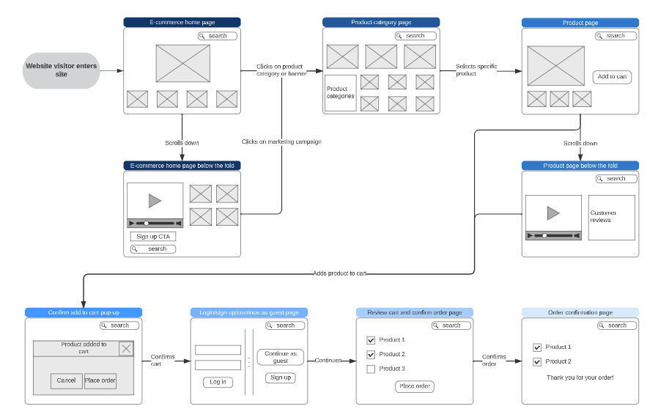

WESITE IS IMPORTANT THINKS ARE:

1. High Availability Architecture:

Design your ecommerce application with redundancy across multiple availability zones to ensure high availability. This minimizes the risk of downtime due to server or data center failures.

2. Scalability:

Plan for scalability to accommodate varying levels of traffic. IBM Cloud provides autoscaling capabilities and allows you to easily add resources to handle increased demand.

3. Data Security:

Implement robust data security measures, including encryption for data in transit and at rest. Leverage IBM Cloud services for key management and encryption.

4. Regulatory Compliance:

Ensure that your ecommerce application complies with relevant industry and regional regulations. IBM Cloud offers resources and tools to help you understand and meet compliance requirements.

5. Monitoring and Analytics:

Utilize IBM Cloud's monitoring and analytics tools to track the performance and health of your ecommerce application. Set up alerts to detect and address issues proactively.

6. DevOps and Automation:

Embrace DevOps practices for automation, continuous integration, and continuous deployment. IBM Cloud provides a suite of DevOps tools to streamline the development and deployment processes.

7. Containerization and Orchestration:

Consider containerizing your application using technologies like Docker and orchestrate them with Kubernetes. IBM Cloud provides managed Kubernetes services for easy deployment and scaling.

8. Load Balancing:

Implement load balancing to distribute incoming traffic across multiple servers. IBM Cloud's load balancing services help optimize performance and ensure even distribution of requests.

9. Backup and Disaster Recovery:

Establish a robust backup and disaster recovery strategy. IBM Cloud offers services for automated backups and solutions for quick recovery in case of data loss or system failures.

10. Content Delivery Network (CDN):

Use IBM Cloud's CDN services to cache and deliver static content closer to users, reducing latency and improving overall application performance.

11. Identity and Access Management (IAM):

Implement strong IAM practices to control access to your IBM Cloud resources. Ensure that only authorized individuals have access to sensitive data and critical components.

12. Customer Support and Service Level Agreements (SLAs):

Consider the level of customer support provided by IBM Cloud and review the SLAs for the services you use. This ensures a reliable and responsive infrastructure for your ecommerce application.

13. Cost Optimization:

Monitor and optimize your costs by leveraging IBM Cloud's cost management tools. This includes using reserved instances, scaling resources based on demand, and optimizing storage costs.